What is it?

Peyronie’s disease was first described in medical literature in 1743, by the French surgeon Francois de la Peyronie. It is a condition which is localised to the penis. It starts with an area of inflammation on the surface (tunica) of the penis, which causes pain on erection and a lump (plaque) which can be felt. As the inflammation is replaced by denser, more fibrous tissue, the plaque becomes firmer and tighter, and the penis becomes curved.

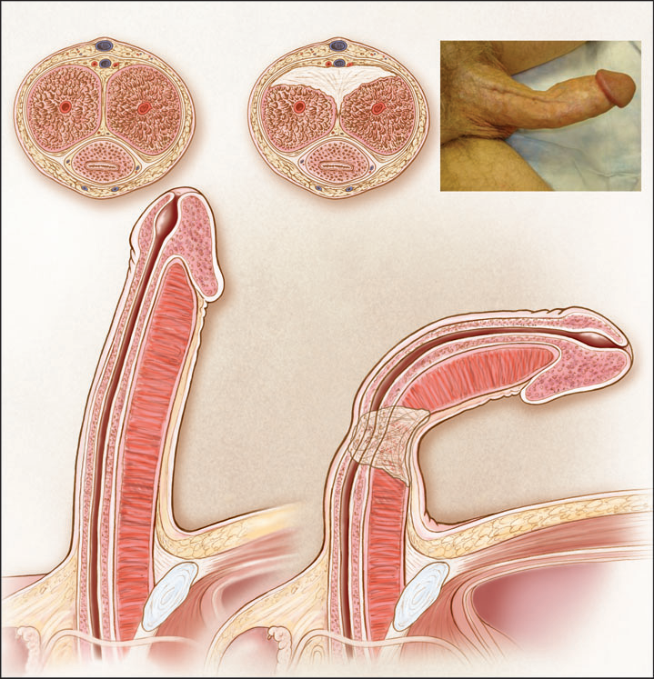
Comparison of a normal penis (left) compared
to one with Peyronie’s disease (right)

Men with Peyronie’s disease often become depressed about the look of their penis (curving, wasting, shortening) and develop a degree of erectile dysfunction (ED). ED is when you are unable to get or keep an erection suitable for sexual intercourse or another chosen sexual activity (more information on ED can be found in our factsheet ‘Erectile dysfunction’). Peyronie’s disease may also cause relationship problems. However, treatments and therapies are available to help this condition.

How common is it?

Peyronie’s disease usually affects men between 30 – 60 years of age, occurring in 3% of the population.

How is it caused?

Why Peyronie’s disease occurs is not fully understood, but it may result from injury to the penis combined with abnormal wound healing. Up to 20% of men with Peyronie’s disease also have a similar condition affecting the hand (Dupuytren’s contraction), and up to 9% have a family member with Dupuytren’s contraction. Men with diabetes, high blood pressure, abnormal lipid (e.g. cholesterol) levels, and low testosterone levels, are at increased risk of developing Peyronie’s disease.

How is it diagnosed?

If you think you have Peyronie’s disease, you should see your doctor for advice and to rule out other medical problems. They will ask you about your condition. They may want to know how long you have had it, if anyone else in your family has had a similar problem, if you have ever injured your penis, and how it affects your sex life. They will probably need to examine your penis. You may need blood tests to check your glucose, lipid and/or testosterone levels. You may also be referred to a hospital specialist for more tests.

How is it treated?

The aims of treatment are to improve penile deformity, sexual function and quality of life. These factors will differ from man to man, so it’s important to discuss what you would like to achieve from treatment, with your doctor.

Treatment should address the way the disease affects your body (physically) and your mind (psychologically). Peyronie’s disease may improve by itself in a small number of men. If it does not, there are various treatments and therapies available to help. These include drug treatments, injection treatment, surgery and psychological therapy (e.g. sex therapy – see the following section on this).

Drug treatment

Drug treatment should be started as soon as possible. Many drugs have been tried for treating the condition. The current favourites include:
Vitamin E 1000mg daily
Pentoxyfylline (e.g. Trental®) 400mg 3x a day
Tamoxifen citrate (e.g. Tamoxifen) 20mg 2x a day
Tadalafil (e.g. Cialis®) 5mg daily

Injection treatment

Once the condition stops getting any worse, patients may be considered for Xiapex® injections directly into the plaque. Xiapex® is a combination of two enzymes which help dissolve the fibrous plaque. Between 3-8 injections are given often in combination with a form of traction therapy.

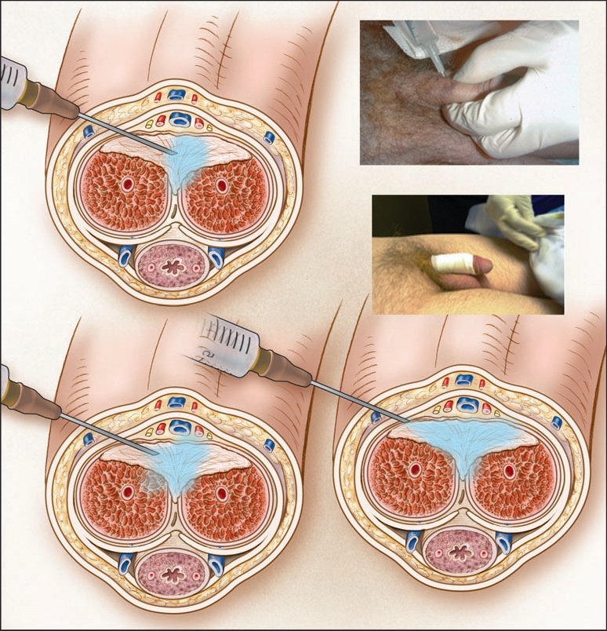
Xiapex® injected into the plaque

Traction therapy

Traction therapy involves daily stretching of the penis with a vacuum or stretching device.

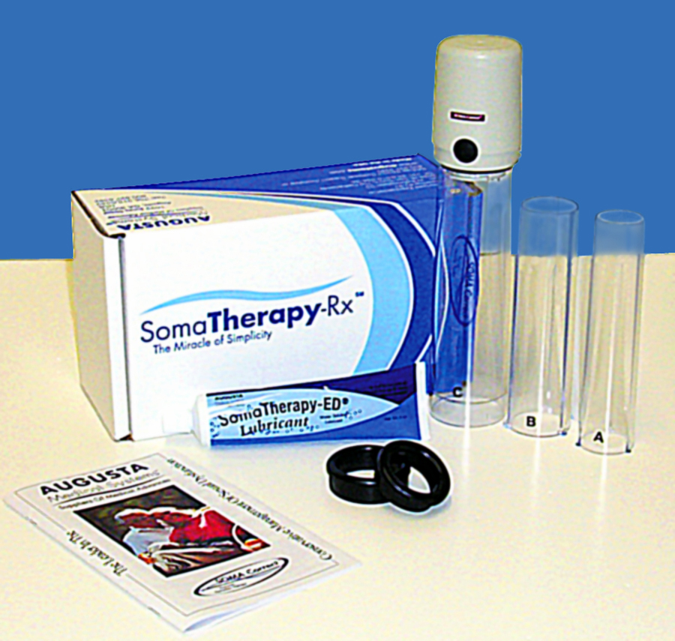
Vacuum device - 20minutes/day

Stretching device - 4 hours/day

Surgery

Approximately 20% of patients will need surgery after failing to improve with drug or injection treatment. Surgery is only advised if the curvature makes penetration difficult or impossible. Many patients with a mild curvature may be able to manage without any surgery, knowing that the condition is unlikely to worsen after one year.

The surgical options include:

- shortening the unaffected side (the Nesbit operation)
- lengthening the scar tissue side (plaque incision and grafting)
- penile implants

The Nesbit operation

The Nesbit operation is a simple operation that straightens the penis without affecting the quality of erections, but it does result in some shortening. This procedure is recommended for men with minor curvatures or some ED.
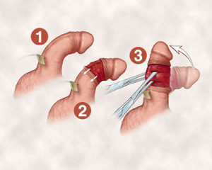

Plaque incision and grafting

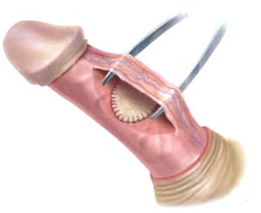
This operation involves cutting the plaque and inserting a graft to lengthen the shorter side of the penis. This procedure is used only for severe or complex curvatures, and it may reduce the quality of erections.

Penile implants

These are reserved for patients that have severe ED and Peyronie’s Disease

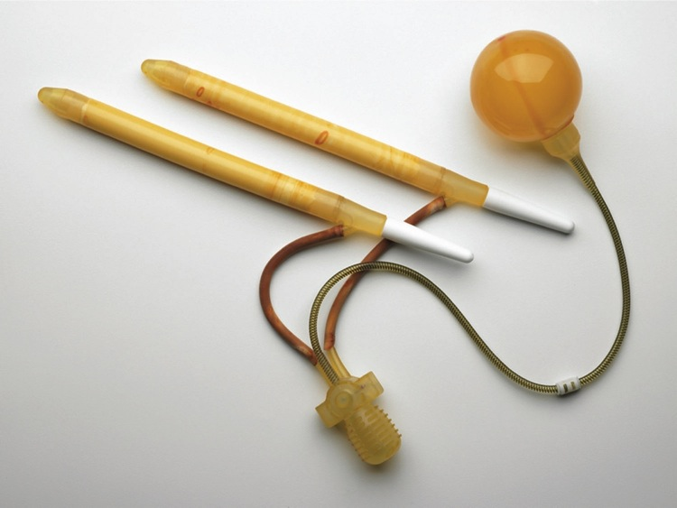

Sex therapy
Sex therapy is talking therapy where an individual or couple work with an experienced therapist to assess and treat their sexual and/or relationship problems. Together they will identify factors that trigger the problems and design a specific treatment programme to resolve or reduce their impact.
Sex therapy is considered highly effective in addressing the main causes and contributing factors of sexual difficulties. And it helps people to develop healthier attitudes towards sex, improve sexual intimacy, become more confident sexually, and improve communication within the relationship.
Sex therapy can also be used in combination with other forms of treatment.
Your GP or another health professional on the NHS may be able to refer you for sex therapy (depending on area), or you can contact a therapist directly and pay privately. It is important to make sure that they are qualified and are registered with an appropriate professional body. You can find more information on sex therapy in our factsheets ‘Sex therapy’ and ‘How to find, choose and benefit from counselling support’
Where can you get more information?

The Sexual Advice Association is here to help. We cannot give individual medical advice, but we can answer your questions on any sexual problems
and put you in touch with local specialist practitioners. We also have a number of factsheets and booklets on sexual problems and related issues for men and women that can be downloaded from our website or requested. Please feel free to email us or phone our Helpline (our contact details are at the bottom of this page).

You can also visit the NHS Choices website at www.nhs.uk/ for information and advice on many different health and lifestyle topics.
What is the Take Home Message?
Peyronie’s disease can seriously affect a man’s quality of life, but help is available – seek advice from your doctor.

Further reading

Download or request our factsheets ‘Explaining sexual problems to your GP’ and/or ‘Testosterone deficiency’

Further help

Association of Peyronie’s Disease Advocates, available at: www.peyroniesassociation.org/
Donate
By donating to the Sexual Advice Association, you will know that you are helping improve the lives of people living with sexual problems. If you are interested in donating, please click here or contact us for more information (details at the bottom of this page).

Thinking About Sex Day: February 14th

Launched by the Sexual Advice Association, Thinking About Sex Day (TASD) is designed to encourage everyone to think about the physical and psychological issues surrounding sexual activity.

